**2018 PEW RESEARCH CENTER’S AMERICAN TRENDS PANEL**

**WAVE 36 June 2018**

**June 19 – July 2, 2018[1]**

Base: ASK ALL

**HAPPYLIFE [S]**

Generally, how would you say things are these days in your life? Would you say that you are…

1 Very happy

2 Pretty happy

3 Not too happy

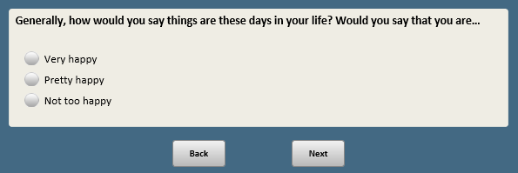

Base: XFORM=1

*Scripter: Randomize and record order of items a-i*

*Scripter: Split onto two screens*

**ESSENPOLF1 [S]**

Thinking specifically about people in high political offices like governors, senators or other top elected officials…

In general, how important, if at all, is it to you for someone in HIGH POLITICAL OFFICE to do each of the following?

a. Be honest and ethical

1 Essential

2 Important, but not essential

3 Not important

b. **[if FORM1A=1]** Be compassionate and empathetic

1 Essential

2 Important, but not essential

3 Not important

c. **[if FORM1B=1]** Be able to work out compromises

1 Essential

2 Important, but not essential

3 Not important

d. **[if FORM1A=1]** Work well under pressure

1 Essential

2 Important, but not essential

3 Not important

e. **[if FORM1B=1]** Be willing to take risks

1 Essential

2 Important, but not essential

3 Not important

f. Stand up for what they believe in, despite political pressure

1 Essential

2 Important, but not essential

3 Not important

g. Be persuasive

1 Essential

2 Important, but not essential

3 Not important

h. **[if FORM1A=1]** Maintain a tone of civility and respect in politics

1 Essential

2 Important, but not essential

3 Not important

i. **[if FORM1B=1]** Serve as a role model for children

1 Essential

2 Important, but not essential

3 Not important

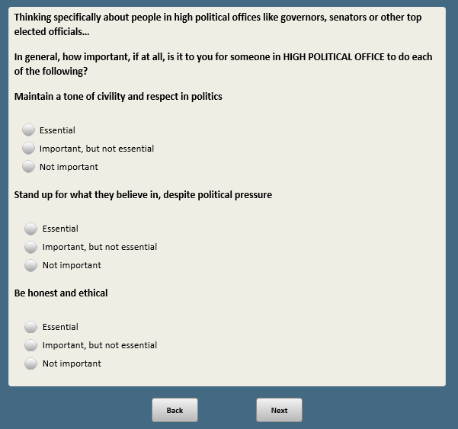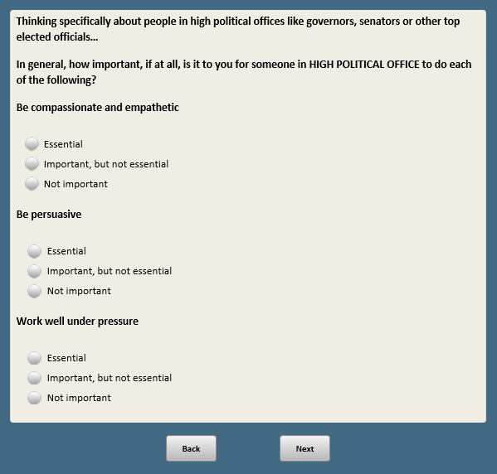

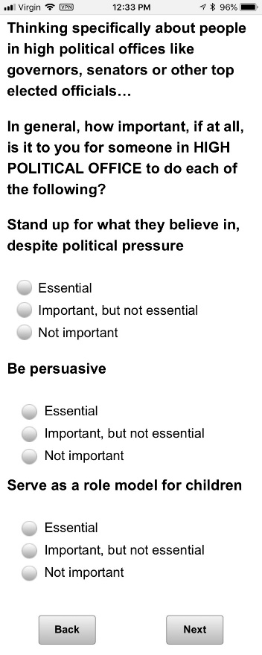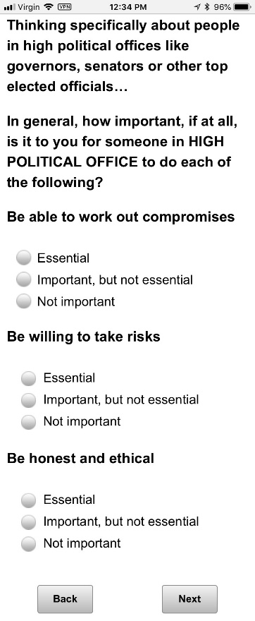

Base: XFORM=2

*Scripter: Randomize and record order of items a-l*

*Scripter: Split onto two screens*

**ESSENBIZF2 [S]**

Thinking specifically about people in top executive business positions…

In general, how important, if at all, is it to you for someone in a TOP EXECUTIVE BUSINESS POSITION to do each of the following?

a. Be honest and ethical

1 Essential

2 Important, but not essential

3 Not important

b. **[if FORM2A=1]** Be compassionate and empathetic

1 Essential

2 Important, but not essential

3 Not important

c. **[if FORM2B=1]** Be able to work out compromises

1 Essential

2 Important, but not essential

3 Not important

d. **[if FORM2A=1]** Work well under pressure

1 Essential

2 Important, but not essential

3 Not important

e. **[if FORM2B=1]** Be willing to take risks

1 Essential

2 Important, but not essential

3 Not important

f. Value people from different backgrounds

1 Essential

2 Important, but not essential

3 Not important

g. **[if FORM2A=1]** Provide fair pay and good benefits

1 Essential

2 Important, but not essential

3 Not important

h. **[if FORM2B=1]** Negotiate profitable deals

1 Essential

2 Important, but not essential

3 Not important

i. **[if FORM2A=1]** Consider the impact of business decisions on society

1 Essential

2 Important, but not essential

3 Not important

j. **[if FORM2B=1]** Provide guidance or mentorship to young employees

1 Essential

2 Important, but not essential

3 Not important

k. Create a safe and respectful workplace

1 Essential

2 Important, but not essential

3 Not important

l. Stand up for what they believe in, despite pressure to make a profit

1 Essential

2 Important, but not essential

3 Not important

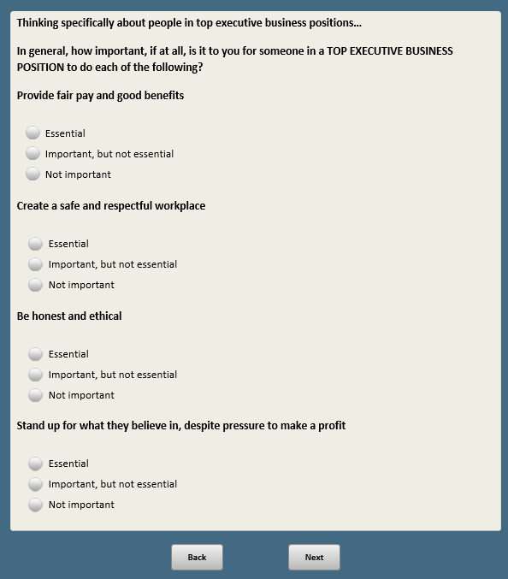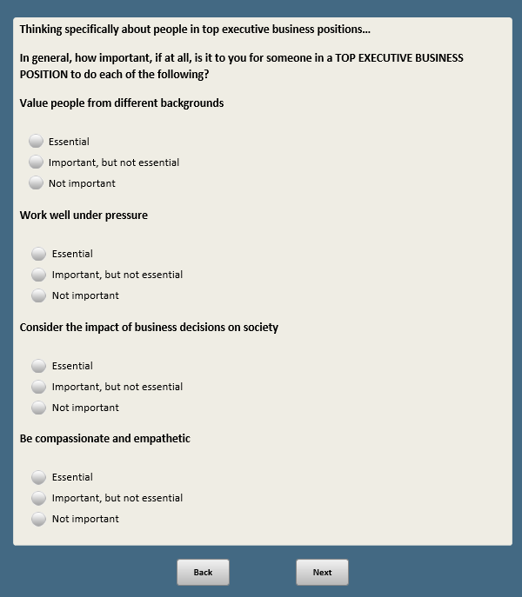

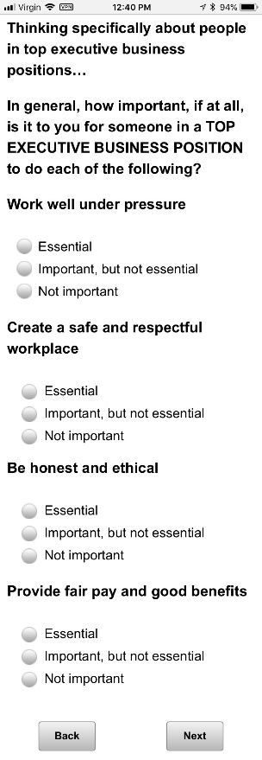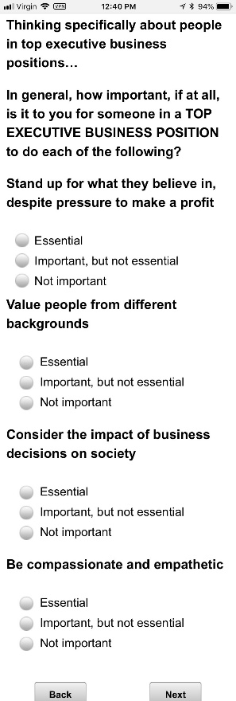

BASE: ASK ALL

*Scripter: Randomize and record response order*

**STYLE1 [S]**

Next, please think about the leadership styles of people in top positions in business and politics.

In general, when it comes to their approach to leadership, do you think that…

1 Men and women are basically SIMILAR

2 Men and women are basically DIFFERENT

**~~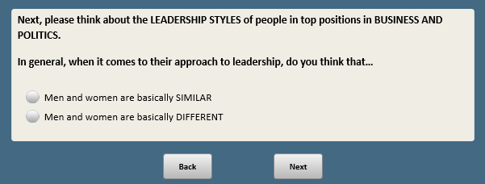~~**

Base: STYLE1=2

*Scripter: Randomize and record response order for 1 and 2. Anchor 3 last.*

**STYLE2 [S]**

Thinking about the ways in which men and women in top positions in business and politics are different in their approach to leadership, would you say…

1 Women generally have a better approach

2 Men generally have a better approach

3 Neither is better **[ANCHOR]**

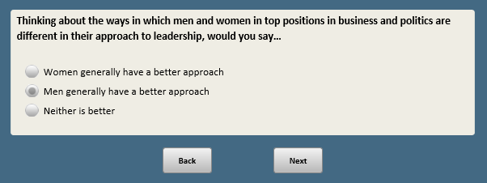

*Scripter: RANDOMIZE BLOCKS AMNTWMNPF1/AMNTWMNP2F1 AND AMNTWMNBF1/AMNTWMNB2F1. Record order.*

Base: XFORM=1

*Scripter: Randomize and record response order for 1 and 2. Anchor 3 last.*

*Scripter: Show in same order as AMNTWMNBF1*

**AMNTWMNPF1 [S]**

Thinking about the country today, would you say there are…

1 Too many women in high political offices

2 Too few women in high political offices

3 About the right number of women in high political offices **[ANCHOR]**

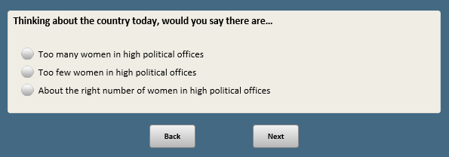

Base: AMNTWMNPF1=2

*Scripter: Randomize and record response order for 1 and 3. Anchor 2 in the middle.*

*Scripter: Show in same order as AMNTWMNB2F1 (if applicable)*

**AMNTWMNP2F1 [S]**

What do you think would be the ideal situation when it comes to the number of women in high political office?

1 Having more women than there are now but still not as many women as men

2 Having about an equal number of women and men **[ANCHOR]**

3 Having more women than men

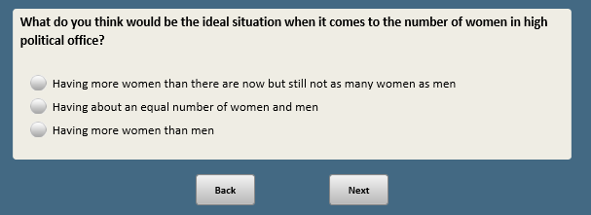

Base: XFORM=1

*Scripter: Randomize and record response order for 1 and 2. Anchor 3 last.*

*Scripter: Show in same order as AMNTWMNPF1*

**AMNTWMNBF1 [S]**

Thinking about the country today, would you say there are…

1 Too many women in top executive business positions

2 Too few women in top executive business positions

3 About the right number of women in top executive business positions **[ANCHOR]**

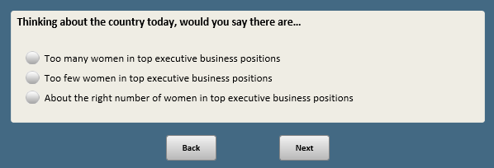

Base: AMNTWMNBF1=2

*Scripter: Randomize and record response order for 1 and 3. Anchor 2 in the middle.*

*Scripter: Show in same order as AMNTWMNP2F1 (if applicable)*

**AMNTWMNB2F1 [S]**

What do you think would be the ideal situation when it comes to the number of women in top executive business positions?

1 Having more women than there are now but still not as many women as men

2 Having about an equal number of women and men **[ANCHOR]**

3 Having more women than men

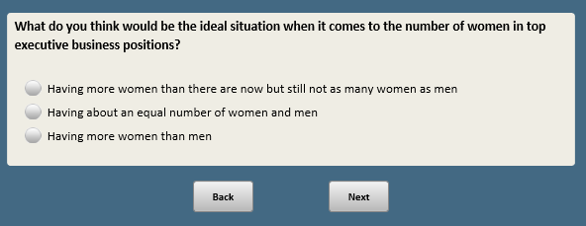

*Scripter: RANDOMIZE EASIERBIZF2 AND EASIERPOLF2. RECORD ORDER. SHOW ON THE SAME SCREEN*

Base: XFORM=2

*Scripter: Randomize and record response options 1 and 2. Anchor 3 last.*

*Scripter: Show responses in same order as EASIERPOLF2*

**EASIERBIZF2 [S]**

Thinking about TOP EXECUTIVE POSITIONS IN BUSINESS these days, would you say it is generally…

1 Easier for men to get these positions

2 Easier for women to get these positions

3 Not much difference **[ANCHOR]**

Base: XFORM=2

*Scripter: Randomize and record response options 1 and 2. Anchor 3 last.*

*Scripter: Show responses in same order as EASIERBIZF2*

**EASIERPOLF2 [S]**

Thinking about HIGH POLITICAL OFFICES these days, would you say it is generally…

1 Easier for men to get elected to high political offices

2 Easier for women to get elected to high political offices

3 Not much difference **[ANCHOR]**

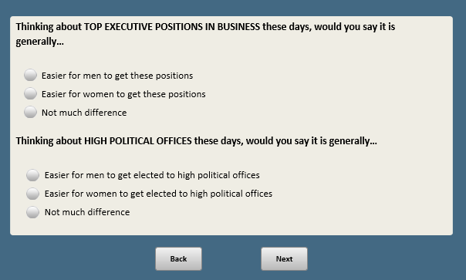

*Scripter: Show EQUALPOLF2 AND EQUALBIZF2 IN SAME ORDER (POL/BIZ) AS EASIERPOLF2/EASIERBIZF2. Show on separate screens.*

Base: XFORM=2

*Scripter: Randomize and record responses.*

**EQUALPOLF2 [S]**

Which of these two statements comes closer to your own view, even if neither is exactly right?

1 As more women run for office, it is only a matter of time before there are as many women as men in high political office

2 Even as more women run for office, men will continue to hold more high political offices in the future

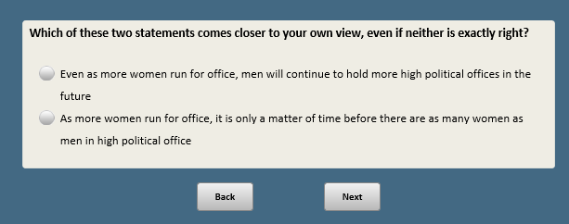

Base: XFORM=2

*Scripter: Randomize and record responses.*

*Scripter: Show responses in same order as EQUALPOLF2*

**EQUALBIZF2 [S]**

Which of these two statements comes closer to your own view, even if neither is exactly right?

1 As more women move into management roles, it is only a matter of time before there are as many women as men in top executive positions in business

2 Even as more women move into management roles, men will continue to hold more top executive positions in business in the future

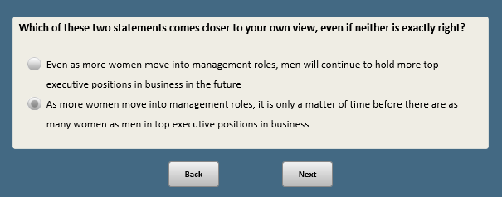

*Scripter: RANDOMIZE IMPROVE1, IMPROVE2 AND IMPROVE3. Record order.*

BASE: ASK ALL

**IMPROVE1 [S]**

How much, if anything, do you think having more women in top leadership positions in business and government would do to improve the quality of life for women?

1 A lot

2 Some

3 Not much

4 Nothing at all

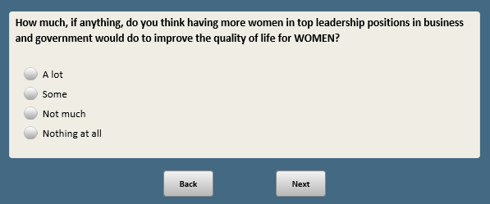

BASE: ASK ALL

**IMPROVE2 [S]**

How much, if anything, do you think having more women in top leadership positions in business and government would do to improve the quality of life for men?

1 A lot

2 Some

3 Not much

4 Nothing at all

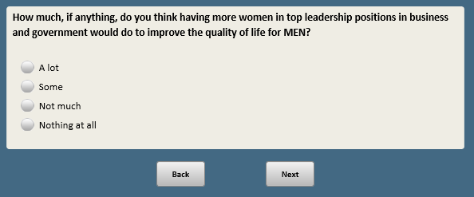

BASE: ASK ALL

**IMPROVE3 [S]**

How much, if anything, do you think having more women in top leadership positions in business and government would do to improve the quality of life for all Americans?

1 A lot

2 Some

3 Not much

4 Nothing at all

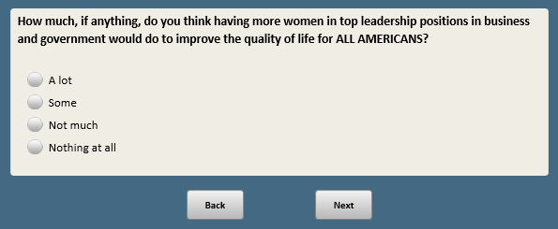

Base: XFORM=1

*Scripter: Randomize and record order of items a-l*

*Scripter: Split onto two screens*

**WHYNOTPOLF1 [S]**

As you may know, fewer women than men occupy high political offices. Here is a list of some possible reasons why. For each of the following, please indicate whether you think it is a reason why there are fewer women than men in HIGH POLITICAL OFFICES.

a. **[if FORM1A=]** Many Americans aren’t ready to elect a woman to higher office

1 Major reason

2 Minor reason

3 Not a reason

b. **[if FORM1B=1]** Women in politics face gender discrimination

1 Major reason

2 Minor reason

3 Not a reason

c. Family responsibilities make it harder for women to run for higher office

1 Major reason

2 Minor reason

3 Not a reason

d. **[if FORM1A=1]** Women aren’t tough enough for politics

1 Major reason

2 Minor reason

3 Not a reason

e. **[if FORM1A=1]** Fewer women have the experience required for higher office

1 Major reason

2 Minor reason

3 Not a reason

f. **[if FORM1B=1]** Women get less support from party leaders

1 Major reason

2 Minor reason

3 Not a reason

g. **[if FORM1A=1]** Women who run for office are held to higher standards than men

1 Major reason

2 Minor reason

3 Not a reason

h. **[if FORM1B=1]** Women who run for office have to do more to prove themselves than men

1 Major reason

2 Minor reason

3 Not a reason

i. Not as many women are interested in holding higher office

1 Major reason

2 Minor reason

3 Not a reason

j. **[if FORM1A=1]** Women aren’t encouraged to pursue leadership positions from an early age

1 Major reason

2 Minor reason

3 Not a reason

k. **[if FORM1B=1]** Women don’t do as good of a job selling their accomplishments

1 Major reason

2 Minor reason

3 Not a reason

l. **[if FORM1B=1]** Sexual harassment creates an environment that makes it harder for women to succeed in politics

1 Major reason

2 Minor reason

3 Not a reason

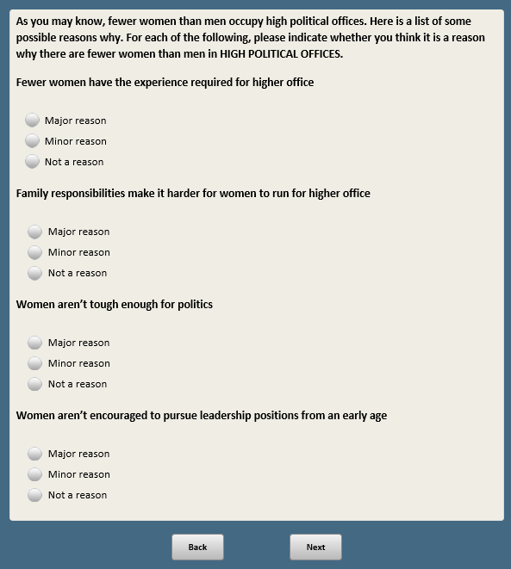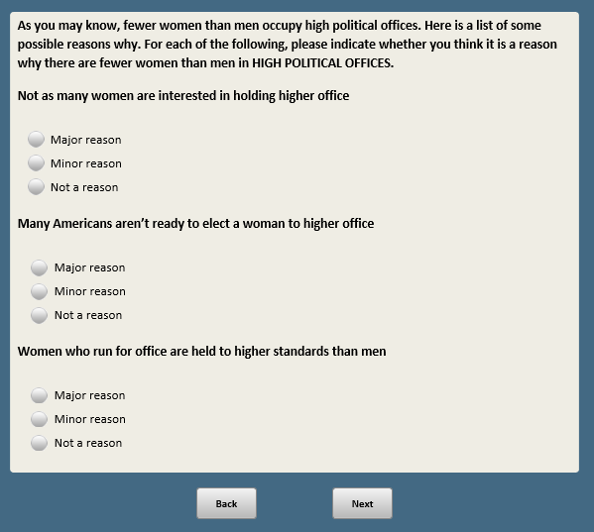

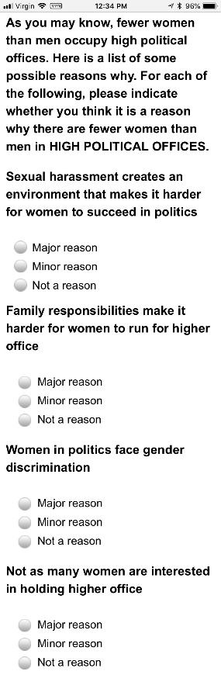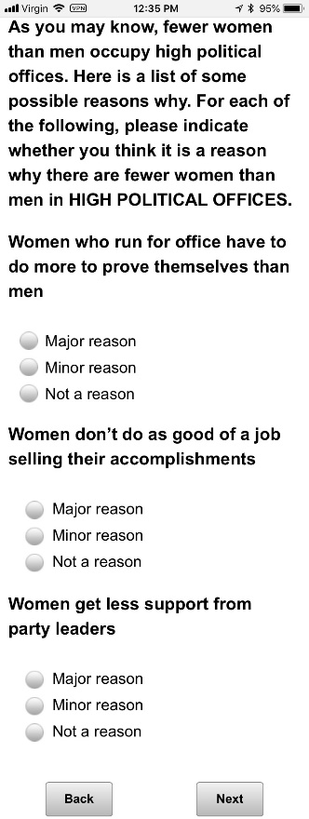

Base: XFORM=2

*Scripter: Randomize and record order of items a-o*

*Scripter: Split onto two screens*

**WHYNOTBIZF2 [S]**

As you may know, very few top executive positions in business in this country are filled by women. Here is a list of some possible reasons why. For each one of the following, please indicate whether you think it is a reason why there aren’t more women in TOP EXECUTIVE BUSINESS POSITIONS.

1. **[if FORM2A=1]** Many businesses are not ready to hire women for top executive positions

1 Major reason

2 Minor reason

3 Not a reason

1. **[if FORM2B=1]** Women in business face gender discrimination

1 Major reason

2 Minor reason

3 Not a reason

1. Family responsibilities make it harder for women to move up in business

1 Major reason

2 Minor reason

3 Not a reason

d. **[if FORM2A=1]** Women aren’t tough enough for business

1 Major reason

2 Minor reason

3 Not a reason

f. **[if FORM2A=1]** Women don’t make as good managers as men

1 Major reason

2 Minor reason

3 Not a reason

g. **[if FORM2A=1]** Women are held to higher standards than men

1 Major reason

2 Minor reason

3 Not a reason

h. **[if FORM2B=1]** Women have to do more to prove themselves than men

1 Major reason

2 Minor reason

3 Not a reason

i. Not as many women are interested in top executive business positions

1 Major reason

2 Minor reason

3 Not a reason

j. **[if FORM2B=1]** Women aren’t encouraged to pursue leadership positions from an early age

1 Major reason

2 Minor reason

3 Not a reason

k. **[if FORM2A=1]** Women don’t do as good of a job selling their accomplishments

1 Major reason

2 Minor reason

3 Not a reason

l. **[if FORM2A=1]** Women don’t have access to the same kinds of personal networks and connections that men have

1 Major reason

2 Minor reason

3 Not a reason

m. **[if FORM2B=1]** Women have fewer opportunities to interact with people in senior positions outside of work

1 Major reason

2 Minor reason

3 Not a reason

n. **[if FORM2B=1]** Women are less likely than men to ask for promotions and raises

1 Major reason

2 Minor reason

3 Not a reason

o. **[if FORM2B=1]** Sexual harassment creates an environment that makes it harder for women to succeed in business

1 Major reason

2 Minor reason

3 Not a reason

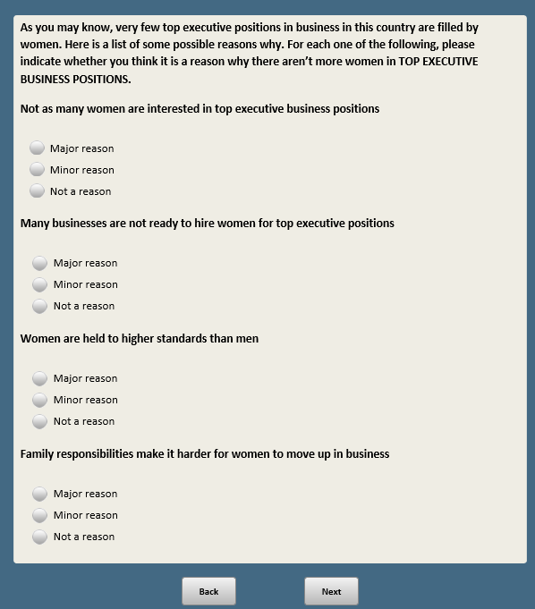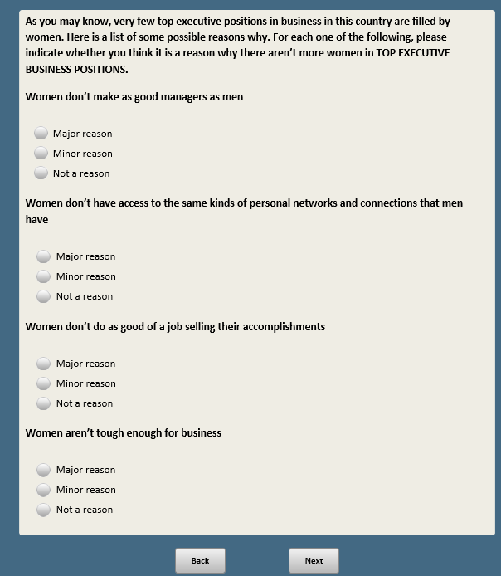

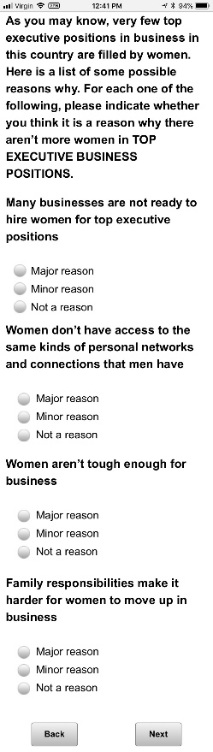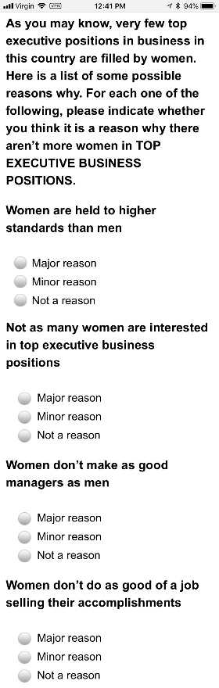

BASE: ASK ALL

*Scripter: Randomize and record response order*

**HIGHED [S]**

Now, thinking about the higher education system, that is colleges and universities, in the United States today…

Do you think the higher education system in the U.S. is generally going in the…

1 Right direction

2 Wrong direction



Base: HIGHED=2

*Scripter: Randomize and record order of items a-d. Never allow items b and c to be next to each other*

**HIGHEDWRNG [S]**

For each of the following, please indicate whether this is a reason why you think the higher education system in the U.S. is going in the wrong direction.

1. Tuition costs are too high

1 Major reason

2 Minor reason

3 Not a reason

1. Professors are bringing their political and social views into the classroom

1 Major reason

2 Minor reason

3 Not a reason

1. Colleges and universities are too concerned about protecting students from views they might find offensive

1 Major reason

2 Minor reason

3 Not a reason

1. Students are not getting the skills they need to succeed in the workplace

1 Major reason

2 Minor reason

3 Not a reason

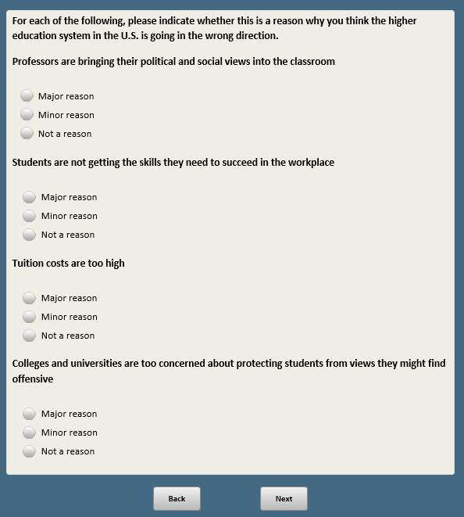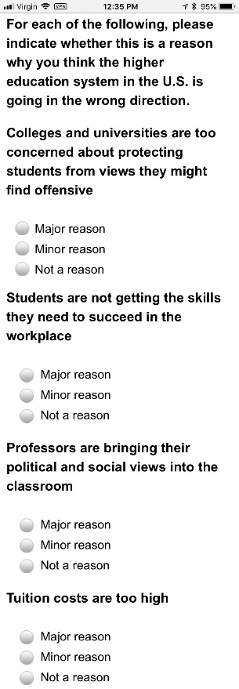

Base: HIGHED=2

*Scripter: Custom prompt if “Yes” is selected and nothing in text box:* You did not provide a response in the text box. If you would like to skip, click Next.

**HIGHEDWRNGS [S]**

Are there any other MAJOR reasons why you think the higher education system in the U.S. is going in the wrong direction?

1 Yes **[O]**

2 No

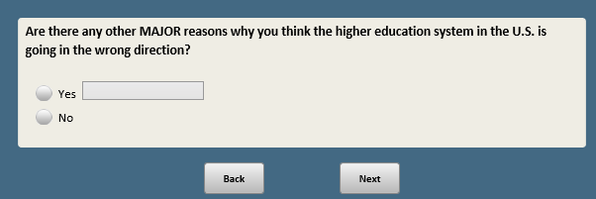

Base: XFORM=1

*Scripter: Randomize and record response items 1 and 2. Anchor 3. Show question stem in same order as responses*

*Scripter: Show items a-I in same order as ESSENPOLF1*

*Scripter: Split onto two screens*

**BETTERPOL1F1 [S]**

In general, do you think **[show in same order as responses:** men or women**/**women or men**]** in HIGH POLITICAL OFFICES are better at each of the following?

a. Being honest and ethical

1 Men are better

2 Women are better

3 No difference **[anchor]**

b. **[if FORM1A=1]** Being compassionate and empathetic

1 Men are better

2 Women are better

3 No difference **[anchor]**

c. **[if FORM1B=1]** Working out compromises

1 Men are better

2 Women are better

3 No difference **[anchor]**

d. **[if FORM1A=1]** Working well under pressure

1 Men are better

2 Women are better

3 No difference **[anchor]**

e. **[if FORM1B=1]** Being willing to take risks

1 Men are better

2 Women are better

3 No difference **[anchor]**

f. Standing up for what they believe in, despite political pressure

1 Men are better

2 Women are better

3 No difference **[anchor]**

g. Being persuasive

1 Men are better

2 Women are better

3 No difference **[anchor]**

h. **[if FORM1A=1]** Maintaining a tone of civility and respect in politics

1 Men are better

2 Women are better

3 No difference **[anchor]**

i. **[if FORM1B=1]** Serving as a role model for children

1 Men are better

2 Women are better

3 No difference **[anchor]**

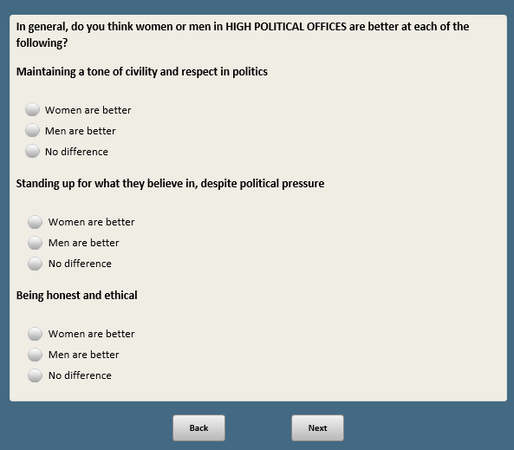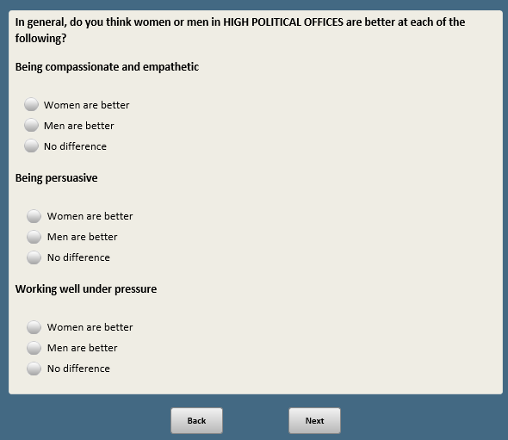

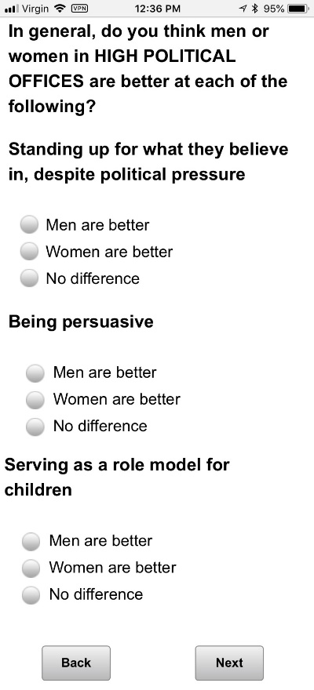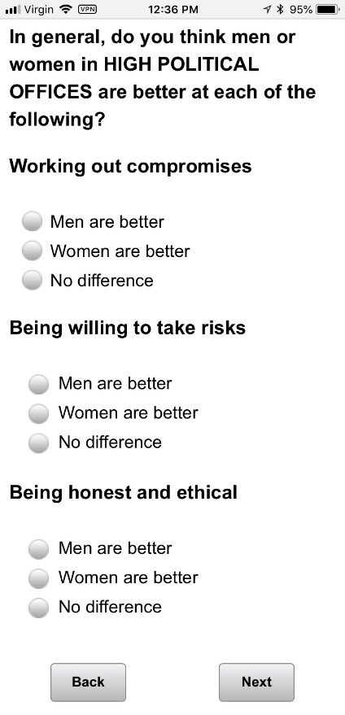

Base: XFORM=1

*Scripter: Show responses in same order as BETTERPOL1F1*

*Scripter: Randomize and record order of items a-f*

**BETTERPOL2F1 [S]**

And thinking about some specific policy areas, in general, do you think **[show in order of responses:** men or women**/**women or men**]** in HIGH POLITICAL OFFICES are better at each of the following?

1. **[if FORM1A=1]** Handling economic conditions

1 Men are better

2 Women are better

3 No difference **[anchor]**

b. **[if FORM1A=1]** Dealing with social issues such as education and health care

1 Men are better

2 Women are better

3 No difference **[anchor]**

c. **[if FORM1B=1]** Dealing with immigration policy

1 Men are better

2 Women are better

3 No difference **[anchor]**

d. **[if FORM1B=1]** Dealing with national security and defense

1 Men are better

2 Women are better

3 No difference **[anchor]**

e. **[if FORM1B=1]** Dealing with the federal budget deficit

1 Men are better

2 Women are better

3 No difference **[anchor]**

f. **[if FORM1A=1]** Dealing with gun policy

1 Men are better

2 Women are better

3 No difference **[anchor]**

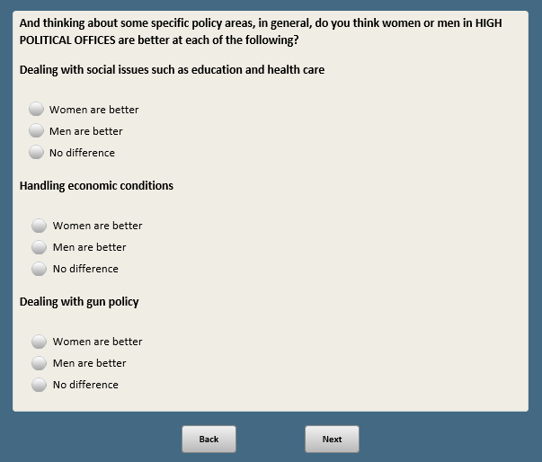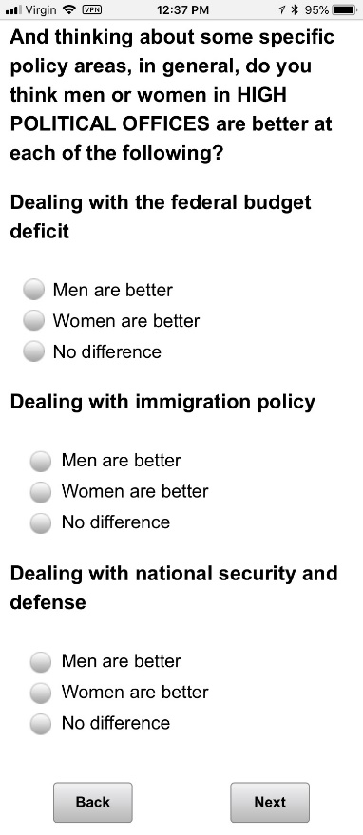

Base: XFORM=2

*Scripter: Randomize and record response items 1 and 2. Anchor 3. Show question stem in same order as responses*

*Scripter: Show items a-I in same order as ESSENBIZF2*

*Scripter: Split onto two screens*

**BETTERBIZ1F2 [S]**

In general, do you think **[show in same order as responses:** men or women**/**women or men**]** in TOP EXECUTIVE BUSINESS POSITIONS are better at each of the following?

a. Being honest and ethical

1 Men are better

2 Women are better

3 No difference **[anchor]**

b. **[if FORM2A=1]** Being compassionate and empathetic

1 Men are better

2 Women are better

3 No difference **[anchor]**

c. **[if FORM2B=1]** Working out compromises

1 Men are better

2 Women are better

3 No difference **[anchor]**

d. **[if FORM2A=1]** Working well under pressure

1 Men are better

2 Women are better

3 No difference **[anchor]**

e. **[if FORM2B=1]** Being willing to take risks

1 Men are better

2 Women are better

3 No difference **[anchor]**

f. Valuing people from different backgrounds

1 Men are better

2 Women are better

3 No difference **[anchor]**

g. **[if FORM2A=1]** Providing fair pay and good benefits

1 Men are better

2 Women are better

3 No difference **[anchor]**

h. **[if FORM2B=1]** Negotiating profitable deals

1 Men are better

2 Women are better

3 No difference **[anchor]**

i. **[if FORM2A=1]** Considering the impact of business decisions on society

1 Men are better

2 Women are better

3 No difference **[anchor]**

j. **[if FORM2B=1]** Providing guidance or mentorship to young employees

1 Men are better

2 Women are better

3 No difference **[anchor]**

k. Creating a safe and respectful workplace

1 Men are better

2 Women are better

3 No difference **[anchor]**

l. Standing up for what they believe in, despite pressure to make a profit

1 Men are better

2 Women are better

3 No difference **[anchor]**

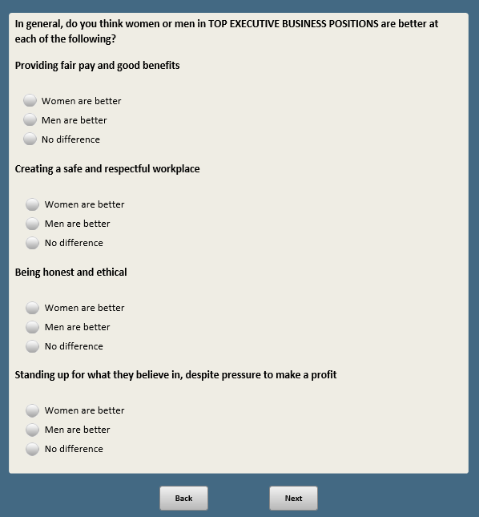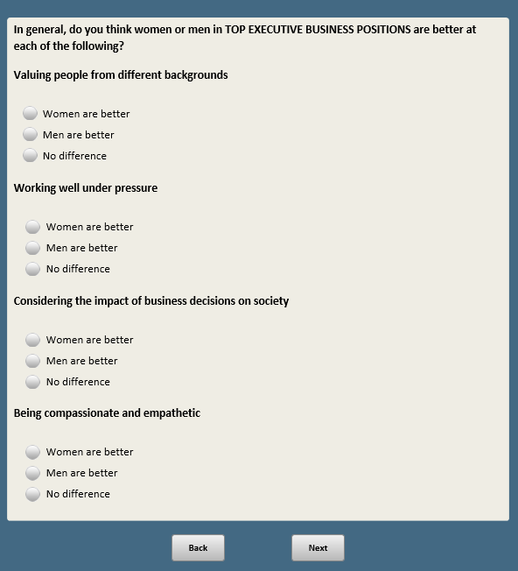

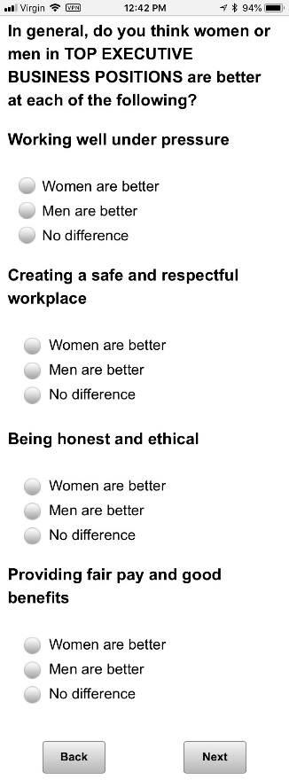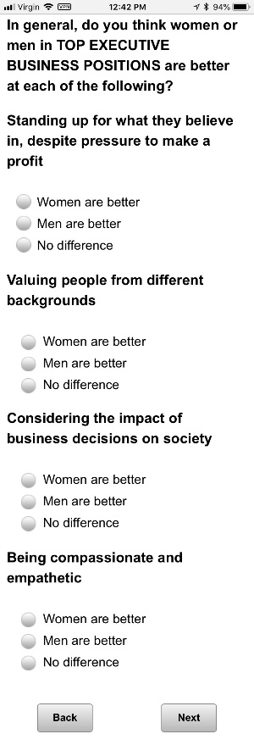

Base: XFORM=2

*Scripter: Show responses in same order as BETTERBIZ1F2*

*Scripter: Randomize and record order of items a-f*

**BETTERBIZ2F2 [S]**

And thinking about different types of companies and organizations…

In general, do you think **[show in same order as responses:** men or women**/**women or men**]** would do a better job running each of the following types of companies?

a. **[if FORM2A=1]** A major technology company

1 Men would do a better job

2 Women would do a better job

3 No difference **[anchor]**

b. **[if FORM2A=1]** A major retail chain

1 Men would do a better job

2 Women would do a better job

3 No difference **[anchor]**

c. **[if FORM2B=1]** A large bank or financial institution

1 Men would do a better job

2 Women would do a better job

3 No difference **[anchor]**

d. **[if FORM2A=1]** A large oil or gas company

1 Men would do a better job

2 Women would do a better job

3 No difference **[anchor]**

e. **[if FORM2B=1]** A major hospital

1 Men would do a better job

2 Women would do a better job

3 No difference **[anchor]**

f. **[if FORM2B=1]** A professional sports team

1 Men would do a better job

2 Women would do a better job

3 No difference **[anchor]**

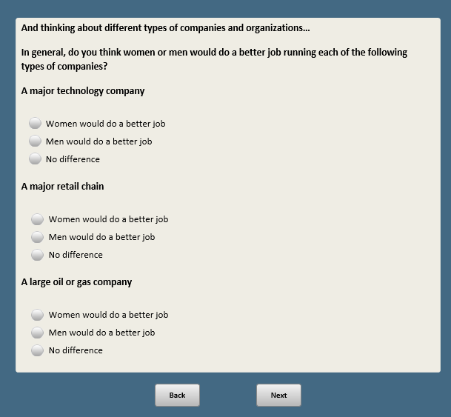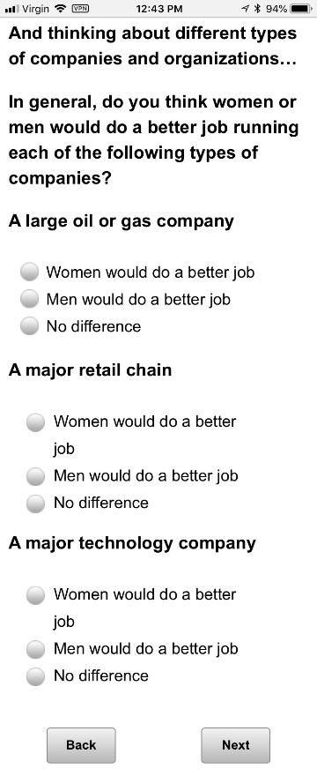

*Scripter: RANDOMIZE TRAITPOLWF1 AND TRAITPOLMF1. RECORD ORDER.*

Base: XFORM=1

*Scripter: Randomize and record order of items a-g*

*Scripter: Randomize and record order of responses 1 and 2. Anchor 3 last.*

**TRAITPOLWF1 [S]**

In general, how do you think each of the following impacts a WOMAN’S chances of getting elected to high political office?

a. Being decisive

1. Mostly helps a woman’s chances
2. Mostly hurts a woman’s chances
3. Doesn’t make much of a difference **[anchor]**

b. **[if FORM1A=1]** Being compassionate

1. Mostly helps a woman’s chances
2. Mostly hurts a woman’s chances
3. Doesn’t make much of a difference **[anchor]**

c. **[if FORM1A=1]** Being ambitious

1. Mostly helps a woman’s chances
2. Mostly hurts a woman’s chances
3. Doesn’t make much of a difference **[anchor]**

d. **[if FORM1A=1]** Being approachable

1. Mostly helps a woman’s chances
2. Mostly hurts a woman’s chances
3. Doesn’t make much of a difference **[anchor]**

e. **[if FORM1B=1]** Being assertive

1. Mostly helps a woman’s chances
2. Mostly hurts a woman’s chances
3. Doesn’t make much of a difference **[anchor]**

f. **[if FORM1B=1]** Showing emotions

1. Mostly helps a woman’s chances
2. Mostly hurts a woman’s chances
3. Doesn’t make much of a difference **[anchor]**

g. **[if FORM1B=1]** Being physically attractive

1. Mostly helps a woman’s chances
2. Mostly hurts a woman’s chances
3. Doesn’t make much of a difference **[anchor]**

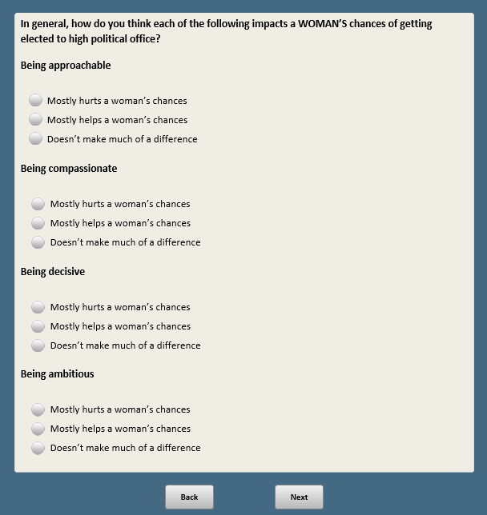**~~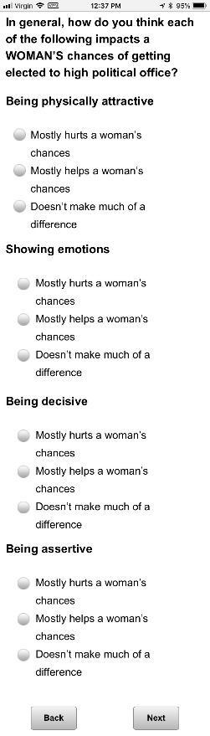~~**

Base: XFORM=1

*Scripter: Show items in same order as TRAITPOLWF1*

*Scripter: Show responses in same order as TRAITPOLWF1*

**TRAITPOLMF1 [S]**

In general, how do you think each of the following impacts a MAN’S chances of getting elected to high political office?

a. Being decisive

1. Mostly helps a man’s chances
2. Mostly hurts a man’s chances
3. Doesn’t make much of a difference **[anchor]**

b. **[if FORM1A=1]** Being compassionate

1. Mostly helps a man’s chances
2. Mostly hurts a man’s chances
3. Doesn’t make much of a difference **[anchor]**

c. **[if FORM1A=1]** Being ambitious

1. Mostly helps a man’s chances
2. Mostly hurts a man’s chances
3. Doesn’t make much of a difference **[anchor]**

d. **[if FORM1A=1]** Being approachable

1. Mostly helps a man’s chances
2. Mostly hurts a man’s chances
3. Doesn’t make much of a difference **[anchor]**

e. **[if FORM1B=1]** Being assertive

1. Mostly helps a man’s chances
2. Mostly hurts a man’s chances
3. Doesn’t make much of a difference **[anchor]**

f. **[if FORM1B=1]** Showing emotions

1. Mostly helps a man’s chances
2. Mostly hurts a man’s chances
3. Doesn’t make much of a difference **[anchor]**

g. **[if FORM1B=1]** Being physically attractive

1. Mostly helps a man’s chances
2. Mostly hurts a man’s chances
3. Doesn’t make much of a difference **[anchor]**

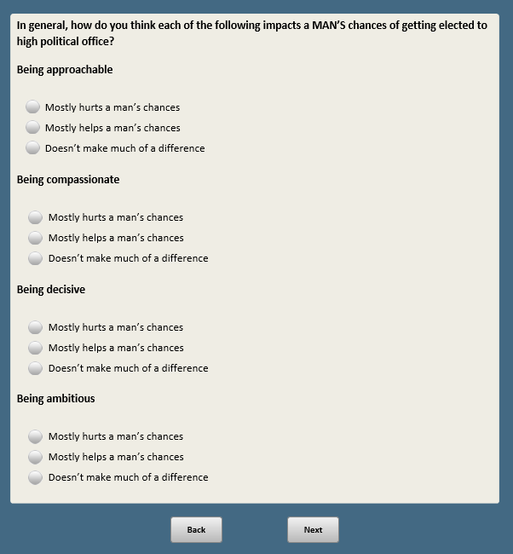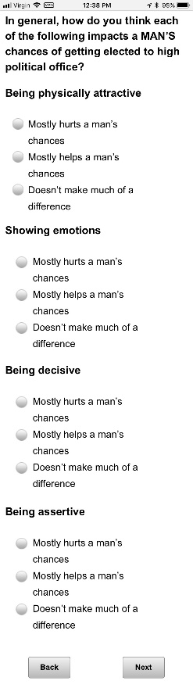

Base: XFORM=1

**POLCHF1 [S]**

In general, what do you think is better for a woman who wants to reach high political office?

1 Having children before she enters politics

2 Waiting until she is well-established in her political career to have children

3 Not having children at all

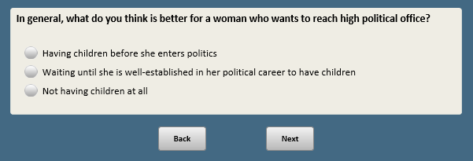

*Scripter: RANDOMIZE TRAITBIZWF2 AND TRAITBIZMF2. RECORD ORDER*

Base: XFORM=2

*Scripter: Randomize and record order of items a-g*

*Scripter: Randomzie and record order of responses 1 and 2. Anchor 3 last.*

**TRAITBIZWF2 [S]**

In general, how do you think each of the following impacts a WOMAN’S chances of getting a top executive business position?

a. Being decisive

1. Mostly helps a woman’s chances
2. Mostly hurts a woman’s chances
3. Doesn’t make much of a difference **[anchor]**
4. **[if FORM2A=1]** Being compassionate
5. Mostly helps a woman’s chances
6. Mostly hurts a woman’s chances
7. Doesn’t make much of a difference **[anchor]**

c. **[if FORM2A=1]** Being ambitious

1. Mostly helps a woman’s chances
2. Mostly hurts a woman’s chances
3. Doesn’t make much of a difference **[anchor]**

d. **[if FORM2A=1]** Being approachable

1. Mostly helps a woman’s chances
2. Mostly hurts a woman’s chances
3. Doesn’t make much of a difference **[anchor]**

e. **[if FORM2B=1]** Being assertive

1. Mostly helps a woman’s chances
2. Mostly hurts a woman’s chances
3. Doesn’t make much of a difference **[anchor]**

f. **[if FORM2B=1]** Showing emotions

1. Mostly helps a woman’s chances
2. Mostly hurts a woman’s chances
3. Doesn’t make much of a difference **[anchor]**

g. **[if FORM2B=1]** Being physically attractive

1. Mostly helps a woman’s chances
2. Mostly hurts a woman’s chances
3. Doesn’t make much of a difference **[anchor]**

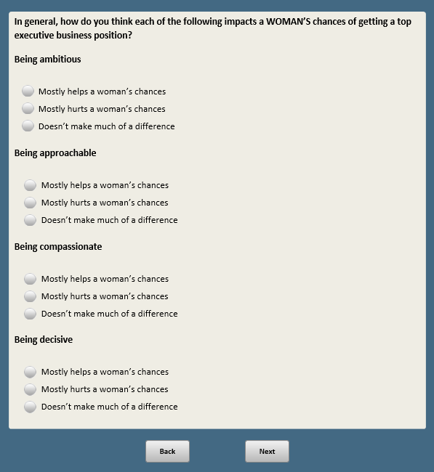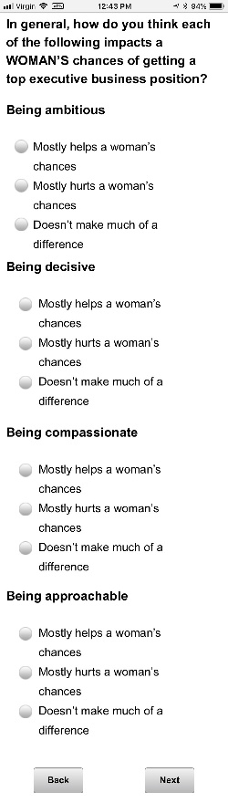

Base: XFORM=2

*Scripter: Show items and responses in same order as TRAITBIZWF2*

**TRAITBIZMF2 [S]**

In general, how do you think each of the following impacts a MAN’S chances of getting a top executive business position?

a. Being decisive

1. Mostly helps a man’s chances
2. Mostly hurts a man’s chances
3. Doesn’t make much of a difference **[anchor]**

b. **[if FORM2A=1]** Being compassionate

1. Mostly helps a man’s chances
2. Mostly hurts a man’s chances
3. Doesn’t make much of a difference **[anchor]**

c. **[if FORM2A=1]** Being ambitious

1. Mostly helps a man’s chances
2. Mostly hurts a man’s chances
3. Doesn’t make much of a difference **[anchor]**

d. **[if FORM2A=1]** Being approachable

1. Mostly helps a man’s chances
2. Mostly hurts a man’s chances
3. Doesn’t make much of a difference **[anchor]**

e. **[if FORM2B=1]** Being assertive

1. Mostly helps a man’s chances
2. Mostly hurts a man’s chances
3. Doesn’t make much of a difference **[anchor]**

f. **[if FORM2B=1]** Showing emotions

1. Mostly helps a man’s chances
2. Mostly hurts a man’s chances
3. Doesn’t make much of a difference **[anchor]**

g. **[if FORM2B=1]** Being physically attractive

1. Mostly helps a man’s chances
2. Mostly hurts a man’s chances
3. Doesn’t make much of a difference **[anchor]**

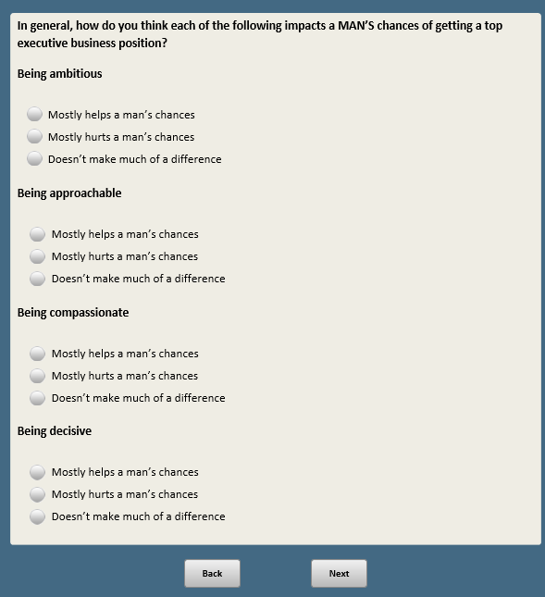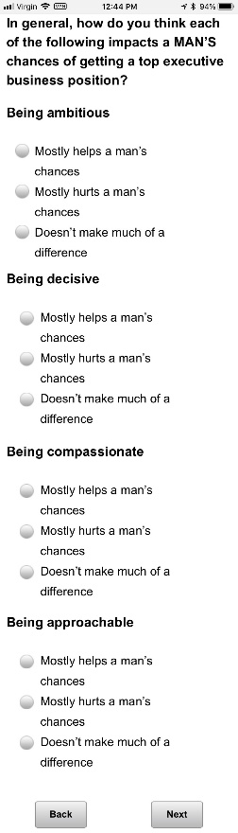

Base: XFORM=2

**EXECCHF2 [S]**

In general, what do you think is better for a woman who wants to reach a top executive position in business?

1 Having children early on in her career

2 Waiting until she is well-established in her career to have children

3 Not having children at all

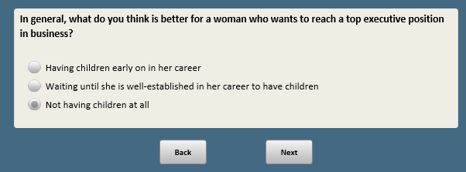

BASE: ASK ALL

*Scripter: Randomize and record order of responses in order 1-4 or 4-1. Show question text in same order*

**WMNPRZ1 [S]**

Do you think it would be a **[show in same order as responses:** good thing or a bad thing**/**a bad thing or a good thing**]** for the country if a woman was elected president?

1 Very good

2 Somewhat good

3 Somewhat bad

4 Very bad

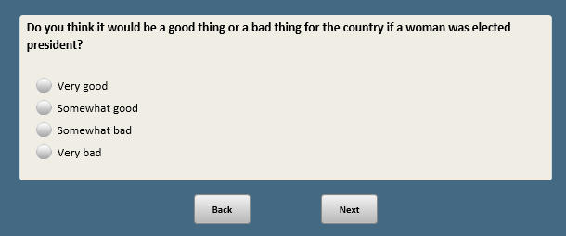

Base: XFORM=1

*Scripter: Allow as many characters as possible*

**WHYMOREF1 [O]**

As you may know, more women are running for U.S. Congress this year than in the past. Why do you think that is the case?

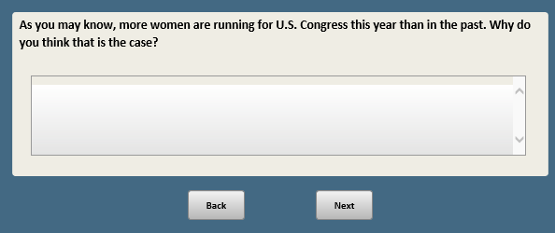

Base: XFORM=2

*Scripter: Randomize and record order of responses 1 and 2. Anchor 3 last*

**MOREWMN1F2 [S]**

As you may know, more women are running for U.S. Congress this year than in the past. Do you think this is…

1 A good thing

2 A bad thing

3 Neither a good thing nor a bad thing **[anchor]**

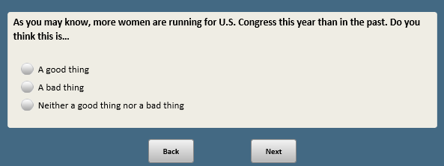

*Scripter: RANDOMIZE MOREWMN2F2, MOREWMN3F2, MOREWMN4F2. Record order*

Base: XFORM=2

*Scripter: Randomize and record responses 1 and 2. Anchor 3 last. Show in same order as MOREWMN3F2 and MOREWMN4F2 (note that better=more and worse=less when randomizing)*

**MOREWMN2F2 [S]**

If there were more women in the U.S. Congress, do you think Congress would…

1 Do a BETTER job of dealing with the country’s problems

2 Do a WORSE job of dealing with the country’s problems

3 The number of women in Congress doesn’t have much to do with this **[anchor]**

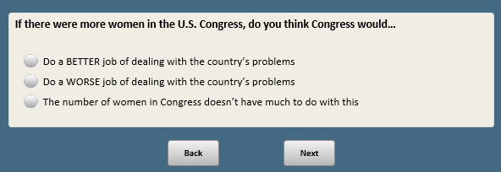

Base: XFORM=2

*Scripter: Randomize and record responses 1 and 2. Anchor 3 last. Show in same order as MOREWMN2F2 and MOREWMN4F2*

**MOREWMN3F2 [S]**

If there were more women in the U.S. Congress, do you think there would be…

1 MORE openness and transparency in government

2 LESS openness and transparency in government

3 The number of women in Congress doesn’t have much to do with this **[anchor]**

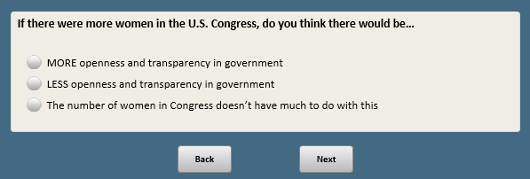

Base: XFORM=2

*Scripter: Randomize and record responses 1 and 2. Anchor 3 last. Show in same order as MOREWMN2F2 and MOREWMN3F2*

**MOREWMN4F2 [S]**

If there were more women in the U.S. Congress, do you think…

1 The tone of political debate in Washington would be MORE respectful

2 The tone of political debate in Washington would be LESS respectful

3 The number of women in Congress doesn’t have much to do with this **[anchor]**

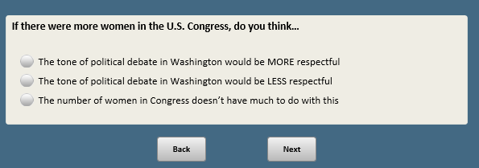

Base: ASK ALL

*Scripter: Randomize and record order of responess*

**COLSPEECH [S]**

Thinking again about colleges and universities…

Which of the following do you think should be more important on college campuses these days?

1 Allowing people to speak their minds freely, even if some students find their views upsetting or offensive

2 Ensuring that students aren’t exposed to views they find upsetting or offensive, even if that limits what people are allowed to say

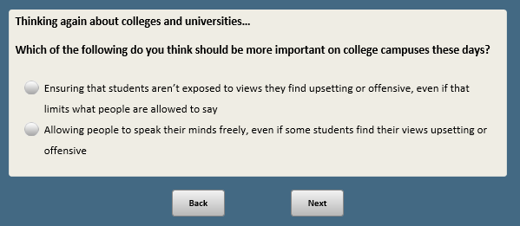

Base: F_MARITAL_FINAL = 1,2

**E5 [S]**

This question is about your household…

Is your **[IF F_MARITAL_FINAL=1:** spouse**;** **IF F_MARITAL_FINAL=2:** partner**]** now employed full-time, part-time or not employed?

1 Full-time

2 Part-time

3 Not employed

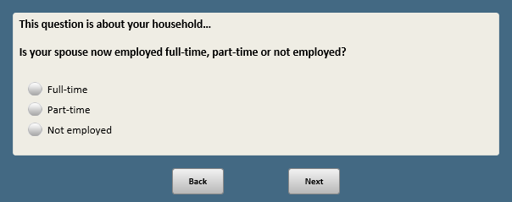

Base: (F_MARITAL_FINAL = 1 or 2) AND ((F_E3_FINAL=1 or 2) and (E5=1 or 2)) (ASK IF MARRIED/LIVING WITH A PARTNER AND BOTH EMPLOYED)

*Scripter: Randomize and record order of responses 1 and 2. Anchor 3 last*

**EARN [S]**

Which of the following applies to your household income**?**

1 I earn more than my **[IF F_MARITAL_FINAL=1:** spouse**;** **IF F_MARITAL_FINAL=2:** partner**]**

2 My **[IF F_MARITAL_FINAL=1:** spouse**;** **IF F_MARITAL_FINAL=2:** partner**]** earns more than me

3 My **[IF F_MARITAL_FINAL=1:** spouse**;** **F_MARITAL_FINAL=2:** partner**]** and I earn about the same **[anchor]**

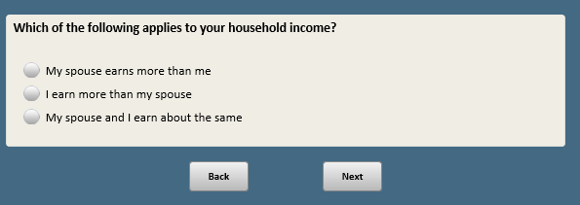

BASE: ASK ALL

**FERTIL1 [S]**

Have you or anyone you know personally ever used fertility treatments to try to have a baby or not?

1 Yes

2 No

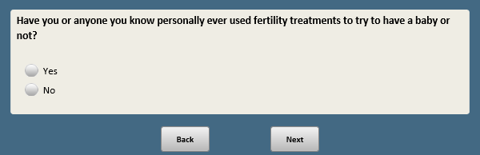

1. Open-end responses are excluded from public datasets to protect the confidentiality of ATP panelists